## RFID Application - Asp.Net Core IIS Setup Instruction

1. IIS Setup

Open IIS -> Select "Application Pool" -> Right click and select "Add Application Pool"

[1]

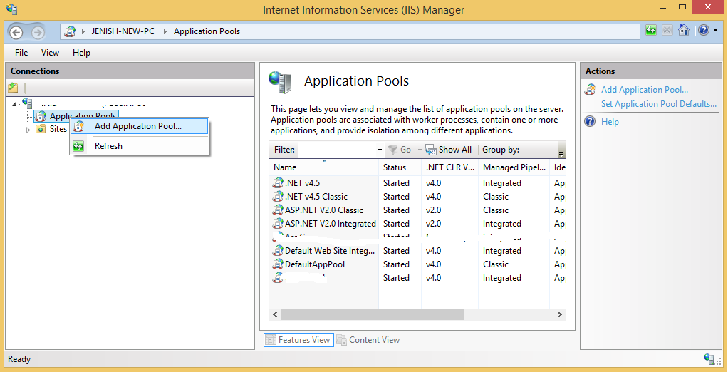

[2]

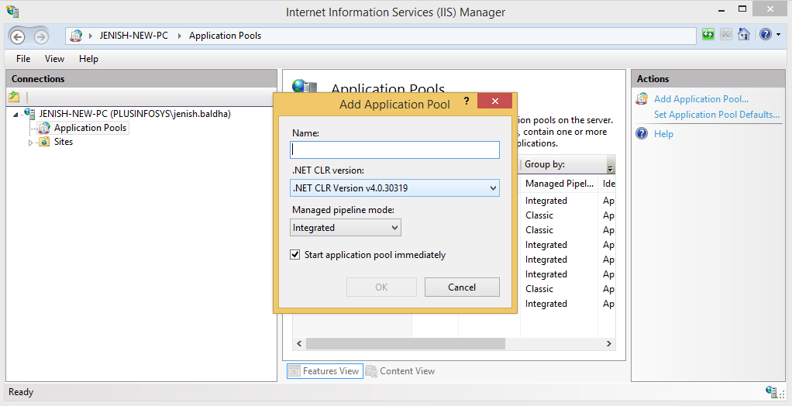

[3] Fill any name related to Asp.Net Core

and

select ".Net CLR Version:" to

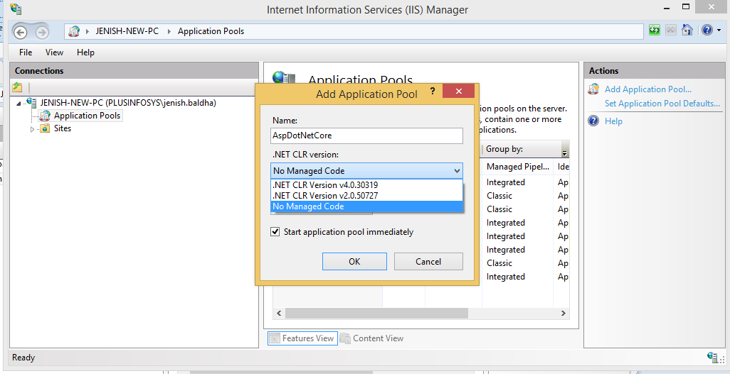

[4]

and select "Managed Pipeline Mode" to "Integrated" and Click "OK"

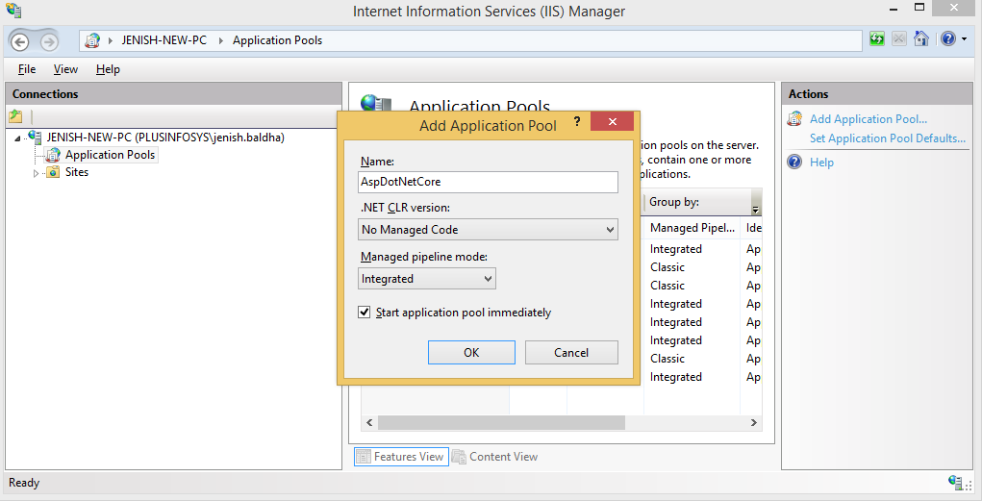

[5]

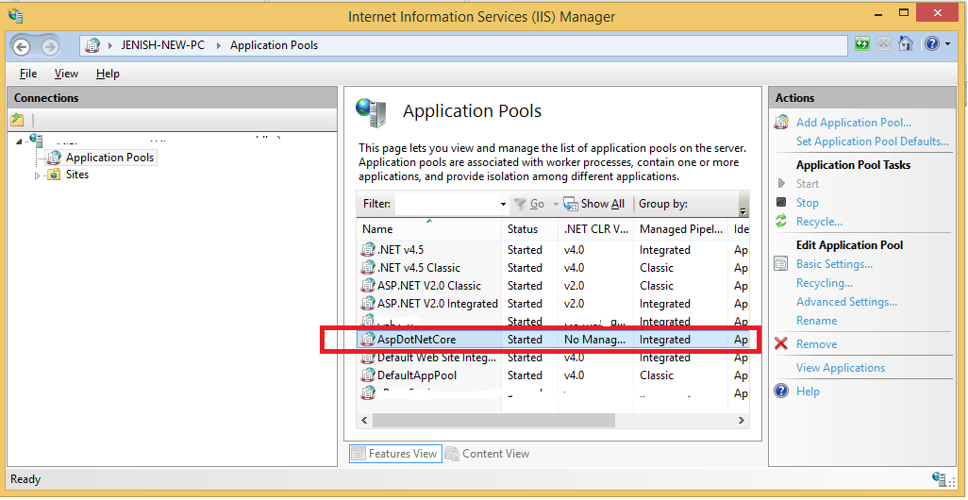

2. Code Setup

Now Click on Sites -> "Default Web Site" -> and on right side click on "Explore"

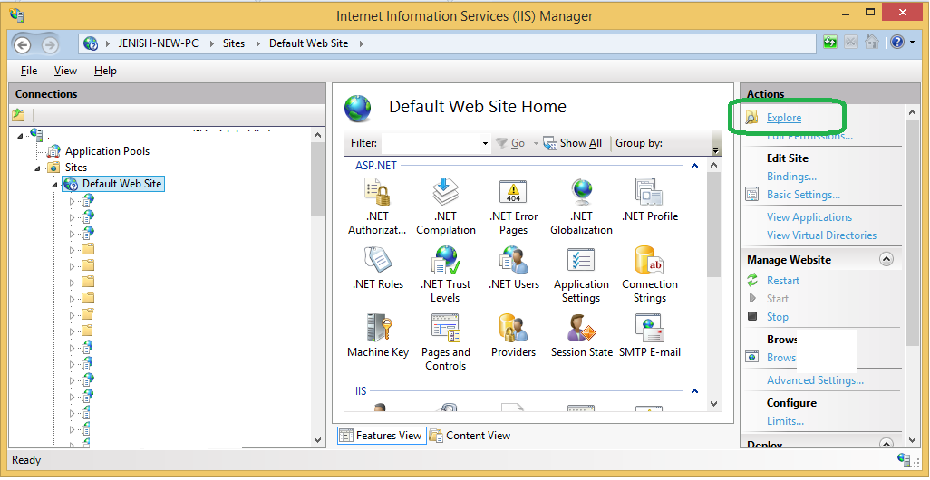

Copy RFIDApplication folder here (RFID_Code_Script.zip->RFID_Code_Script\Code\RFIDApplication)

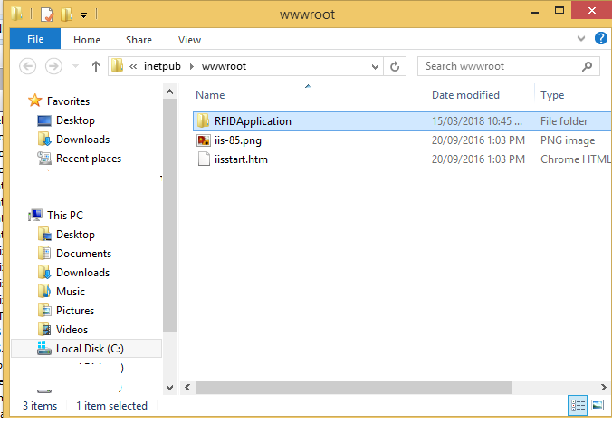

Now check on IIS and Refresh "Default Web Site"

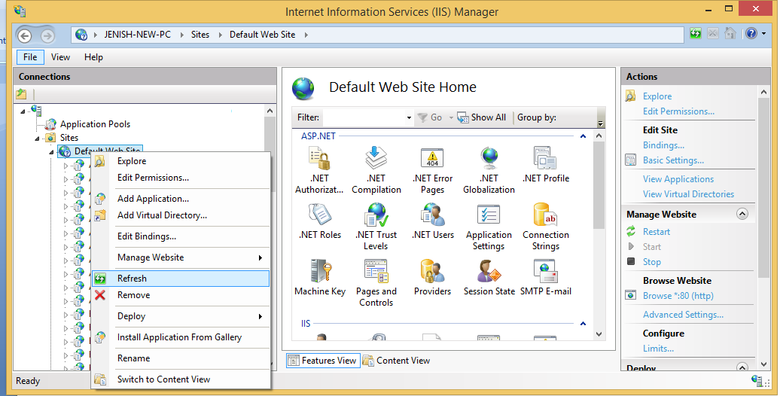

Folder will Display

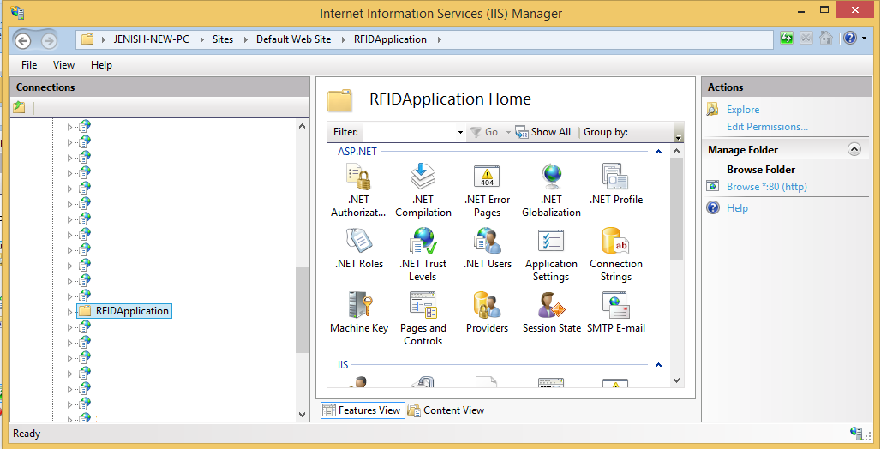

Now Right click folder and select "Covert to Application"

[1]

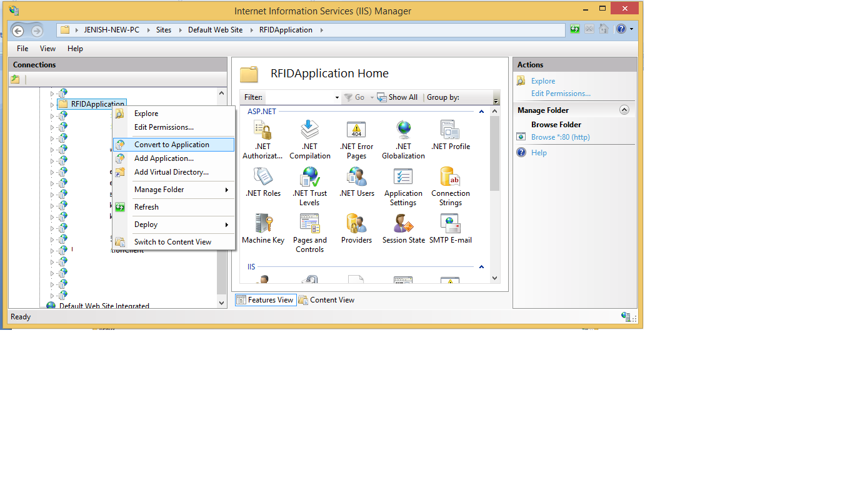

[2] and Click on "Select..." button

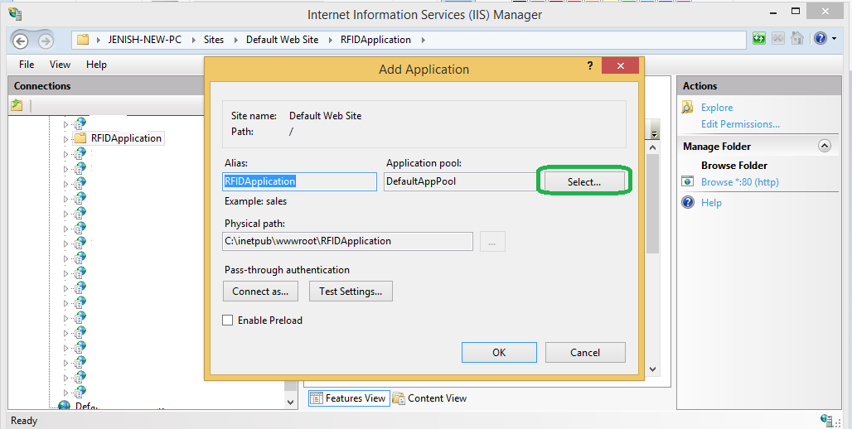

[3] select "Application Pool" which is created for Asp.Net core Click "OK" and "Add Application"

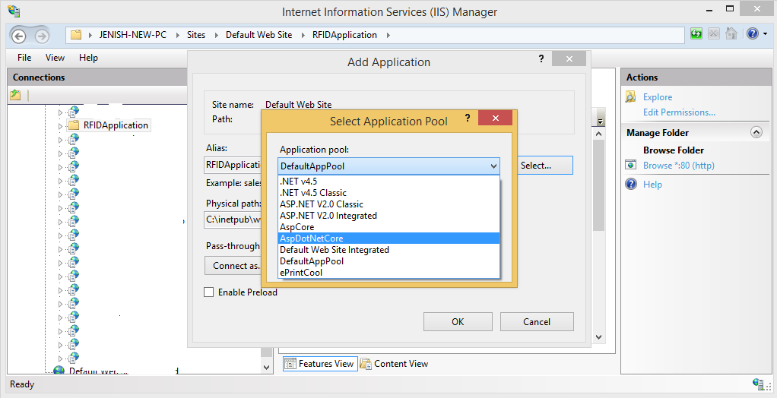

Now click on "Edit Permission"

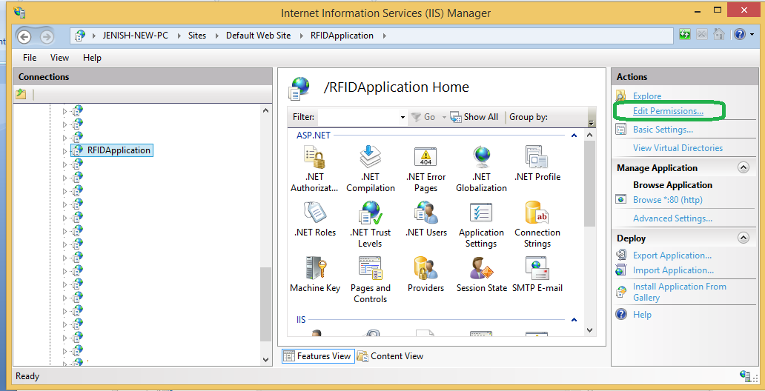

[2] on "Security" tab select "IIS_Users"

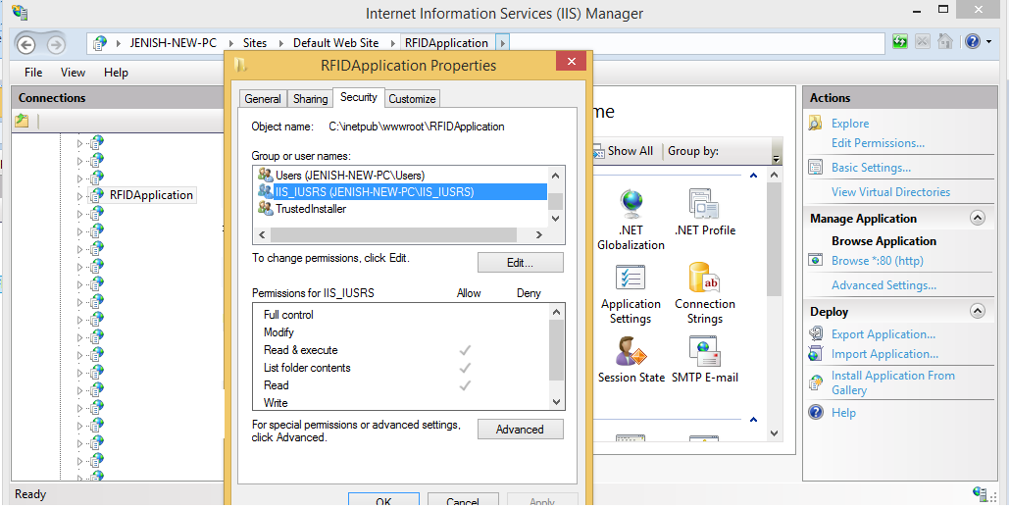

[3] and click on "Edit" and again select "IIS_USERS" and give "Full control" and click "OK"

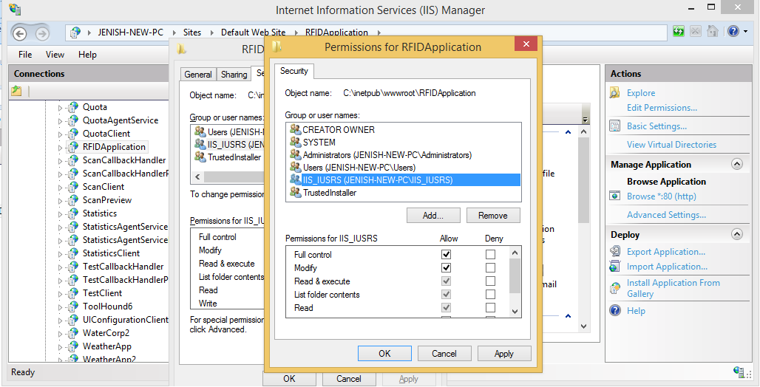

3. Database connection Setup

To change database connection string again "Explore" "RFID Application" folder

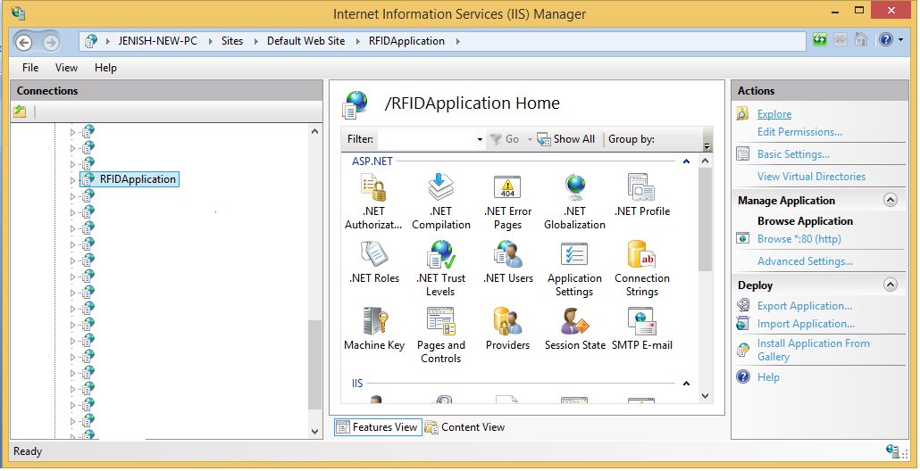

and open "appsettings.json" file

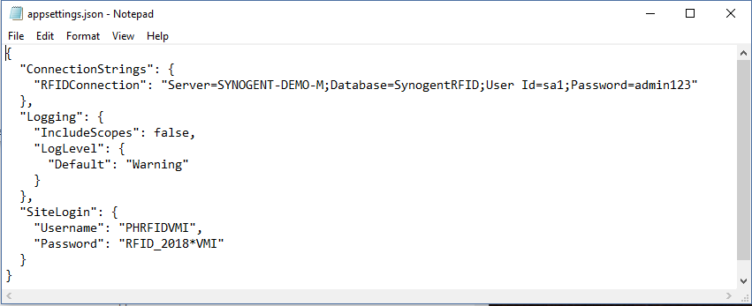

Change the RFIDConnection value to the connection string for the deployed database instance.

(optional) Change the Username and Password values under SiteLogin to reflect the desired login credentials for the website.